Newsletters

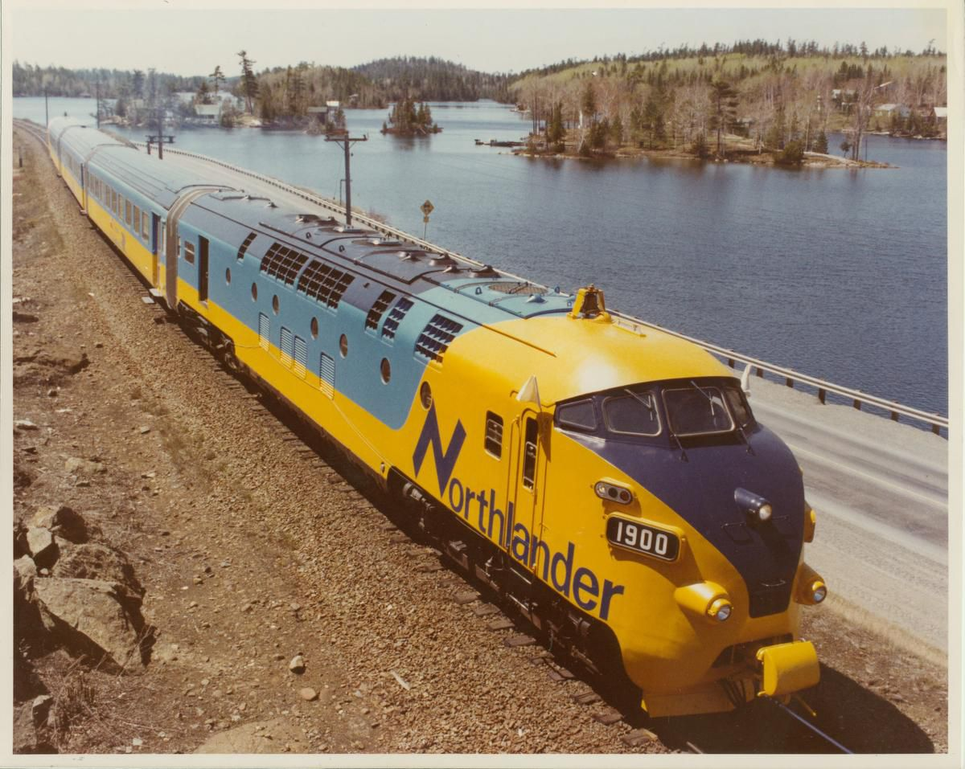

Ontario’s main parties are pledging to restore Northlander train service. Voters are worried they may be taken for a ride — again

Even a decade later, feelings about the loss of the 110-year-old rail link are still raw.
By Kristin Rushowy Queen's Park Bureau Sun., May 15, 2022

NORTH BAY — Northerners hope they aren’t being taken for a ride.
All four major parties are promising that the Northlander trains — axed in 2012 by the then-Liberal government looking to cut costs — will get back on track if they are elected.
But it’s not the first time a pledge has been made to resume — or even look at the possibility of resuming — the service that connected Cochrane down through North Bay and then south to Toronto.
Even a decade later, feelings about the loss of the 110-year-old link are still raw. During last week’s first leaders’ debate when the Northlander was mentioned, someone in the audience would yell “shame.”
People have missed medical appointments when the two-lane highways are shut down because of an accident, or the weather. Or they simply choose not to travel south because they can’t face the long drive — or don’t want to take the buses that replaced the Northlander service. Others have died in accidents on portions of northern highways that are considered poorly designed and unsafe, regardless of the time of year.
“Every municipality in northern Ontario has passed a resolution asking for the reinstatement of passenger rail,” said Danny Whalen, a Temiskaming Shores city councilor who is president of the Federation of Northern Ontario Municipalities.
The federation hosted last week’s first leaders’ debate of the provincial election. At the end, Whalen took to the podium for final remarks, saying he feels sorry for the leader who wins June 2.
“I probably shouldn’t have, but I told them ‘I’ll be in your face from Day One’ after the election,” he said in an interview, adding that on the Northlander issue “I don’t want sympathy. I want action.”
A northern rail service would help build the northern economy, support freight rail, bring good-paying jobs, and also boost tourism, said Lucille Frith, co-chair of the Northeastern Ontario Rail Network who has been working on bringing back the Northlander since 2007 during the restoration of the Huntsville train station.
The loss of the trains “meant many people and businesses and tourists could not connect with a part of the country they wanted to connect with there,” she said. “There are ways to get around by other modes of transportation, but the train was an ideal way to get through the vast distances of northern Ontario in a comfortable and reasonably economical and safe — and 365-days-of-the-year — connection.”
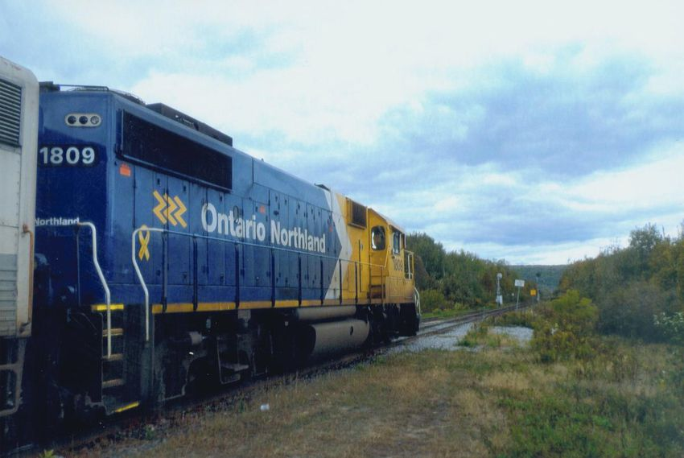
While bus service has improved over the years, having trains “meant being connected to business to families,” she added. “It was a safe mode of transportation, especially for those who either didn’t have a vehicle or did not wish to drive a vehicle depending on conditions of the weather.”
Regardless of the party that wins the election, it will take two to three years to order the rolling stock, and Frith said she wishes that the PC government had passed its budget and a promised $75 million so that trains could have been purchased sooner.
She said over the years locations and stops have been identified and all municipalities would need to be involved to market the rail and tourism and business opportunities.
Because the PCs promised to return the Northlander in the 2018 election, Frith said if they form the next government and “if they don’t move, they will once again have not completed a promise. And quite honestly ... if you end your term with a budget that was never passed, and you end up being elected, then I would expect the first week you’re going to write the authorization for that purchase order.”
While all parties have pledged to return the Northlander, the Liberals have gone a step further and said their buck-a-ride promise would also include those trains.
“Losing the Northander was like a stake in the heart for many of us,” said New Democrat MPP John Vanthof, who represents Timiskaming—Cochrane and in a typical year drives about 120,000 kilometres to and from Toronto from his home in Cobalt. “The Northlander was emblematic, our railroad link to the south. And it was a big shock when the Liberals just cancelled it with no warning and no debate.”
The Northlander, he added, “has not been forgotten at all — and especially now that we are seeing a pretty big influx of people moving north. And one of the questions that people always ask is ‘OK, so what public transportation is there?’ …It’s coming up more and more that if we are going to keep and attract people that we need, we need a train link.”
Ontario Northland and Metrolinx recently released a business case for the return of train service up north, saying that the service would still need to be subsidized, but less so than when the Liberals axed it. They have also conducted a test run to time travelling between Toronto and North Bay.
The Northern Policy Institute, however, has said there is no real economic case to be made for the train, but urged further study.
Martin Collier, director, Healthy Transport Consulting and founder of Transport Futures, said the service is likely to resume in the mid-2020s, and noted that governments subsidize all kinds of public transportation including the UP Express linking Union Station to Pearson Airport.
However, $75 million is not enough, he added.
“I think they have to provide the service — they can’t just keep investing in highways as the only way for people to get around,” said Collier.
Transport Futures is holding a provincial election transportation debate on May 25.
Chris James Drew, an urban planning expert, rode the Northlander as a child and said renewed attention to the train service comes from “a confluence of issues” including environmental congestion, the price of gas and the cost of driving — and interest in staycation tourism fuelled by pandemic travel concerns.
Drew said that expanding rail passenger service is difficult because the province doesn’t own all of the tracks “so it’s difficult and takes time ... but I want my taxpayer dollars to go to a project that’s going to bring more tourism and people to the north — and I live in downtown Toronto.
“I think there’s a huge tourism opportunity with the line — both from people from the north coming south and people who are going north. It’s a gateway to explore the rest of Ontario.” JOHN VANTHOF

Kristin Rushowy is a Toronto-based reporter covering Ontario politics for the Star. Follow her on Twitter: @krushowy

