MEDIA RELEASE October 12, 2018

NORTHEASTERN ONTARIO RAIL NETWORK (NEORN) LOOKS FORWARD TO IMPLEMENTATION OF PREMIER FORD'S PROMISE RE: PASSENGER RAIL

It has been 6 months since our PC Leader (now Premier) Doug Ford promised to bring back full passenger rail service to the North. At the time, this was welcome news should they be elected.
Now they have been elected and Northerners are anxious to see this promise happen.

For the past 5 years NEORN has been busy encouraging Northern Ontario municipal councils, First Nation councils and organizations, the Canadian Federation of Students, economic development organizations as well as several federal and provincial politicians to pass resolutions of support for the return of passenger rail to northern Ontario. Last week NEORN provided to Premier Ford and Northern Ontario MPPs copies of these resolutions from virtually every community on the Toronto-Cochrane rail line from Washago north as well as the Algoma Central Rail line from the Sault to Hearst.

As NEORN spokespeople state in their recent Northern Policy Institute commentary, the NEORN LOOP is a “modern, innovative, comprehensive and integrated passenger rail service (that) could radically enhance Northern Ontario’s regional intercommunity connectivity and do so using existing rail infrastructure” along with bus feeder lines to provide service to Northern Ontario and connect it with southern Ontario and the rest of Canada.
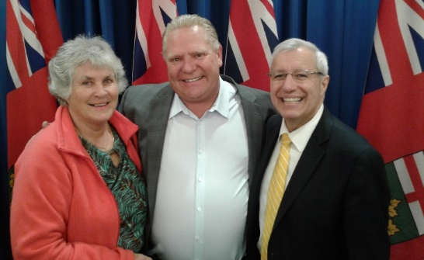
Northern Ontario Rail Service Promised
May 3 North Bay - Lucille Frith, NEORN Co Chair meets Ontario PC Leader Doug Ford and MPP Vic Fedeli

In the past year, another group calling itself 'All Aboard Northern Ontario' has developed a proposal entitled 'NortheastLynx’, a plan to revive the Northlander route. NEORN welcomes this initiative and any others that may come forth to get this train service back on the rails.

To the Provincial government, the ball is in your court.
Time to act and make good on your promise of restoring rail passenger services in the North.

NEORN CO-CHAIRS: Lucille Frith Howie Wilcox
705-789-8903 705-942-9990

https://www.northbaynipissing.com/news-story/8589161-ford-promises-new-northlander-to-nipissing-voters/
NPI commentary “Actions to Move Ontario Forward, Passenger Rail” https://www.northernpolicy.ca/upload/documents/news-releases/en-press-release-multimodal-series-4-pas.pdf

